**AMAZON’S EMPLOYEE BUS PASS MANAGEMENT APPLICATION**

**USER**

**MANUAL**

*Bikash Bhagat*

**INDEX**

----------------------------------------------------------------------------------------------------------------

**Introduction**

1. Application Home Page
2. Admin Login Page
3. Admin Operations Page  
   3.0. Admin Operations Menu  
   3.1. Bus Control Menu  
    3.1.1. Add a New Bus  
    3.1.2. Remove an Existing Bus  
    3.1.4. Show All Buses

3.2. Route Control Menu

3.2.1. Add a New Route  
 3.2.2. Remove an Existing Route  
 3.2.3. Add a New Stop

3.2.4. View All Routes With Their Stops

3.3. Change Bus & Route Assignments

3.4. Change Bus Type Menu  
 3.4.1. Change Type Of an Active Bus

3.4.2. Change Type Of an Inactive Bus

3.4.3. Show All Buses

3.5. Display Number of Buses Of Each Type

3.6. Display Start Timings And Route For Each Bus

1. User Login/Signup Page  
   4.1. Existing User  
   4.2. New User
2. User Operations Page   
   5.0. User Operations Menu  
   5.1. View Available Routes  
   5.2. Update Profile  
    5.2.1. Update Profile - Field Selection Menu  
    5.2.2. Update Name

5.2.3. Update Email Address  
 5.2.4. Update Contact Number  
 5.2.5. Update Emergency Contact Details

5.2.6. Password  
5.3. Raise Request For a New Route  
5.4. Raise Request For a Bus Pass

5.5 Provide Feedback

1. Visitor Operations Page  
   6.1. Visitor Operations Menu  
   6.2. View Details For Available Routes and Buses  
   6.3. Display Seat Availability

**A Message From The Creator**

# **INTRODUCTION**

Some key points to remember while using the application :

* Throughout the application, you will be requested to input values from your keyboard.
* All menus throughout the application are controlled via numbered options.
* To make successful selections, you must input the number of your choice from the options displayed in each of menus throughout the application.
* Entering an invalid input in a menu, will refresh the page with a message.
* Entering an invalid input in a field, will show a message with the reason for the input being invalid and then can either take you back to the previous menu or, you will be allowed to enter the values again. [ such as while loging in, changing password,etc.]
* If you want to return to the previous menu from any of the sub-menus, press ‘0’ on the menu page.
* If you want to return to the previous page from a non-menu location such as while entering inputs in a form, press ‘Enter twice’.

The Rule is not applicable in certain sensitive scenarios, such as while logging in as an Admin & User Or, while changing passwords. In such cases, multiple tries are provided, hence all tries must be exhausted to return to the previous page.

Keeping these key points handy will make sure that you have a seamless experience with the application.

# 

# **1. APPLICATION HOME PAGE**

This page welcomes customers to the application.

Currently, 3 user types are supported with each having their own features.

1. Admin - Takes to the Admin Login Page
2. User - Takes to the User Menu Page
3. Visitor - Takes to the Visitor Operations Page
4. Exit - Exits the Application

Enter the option of your choice to proceed.

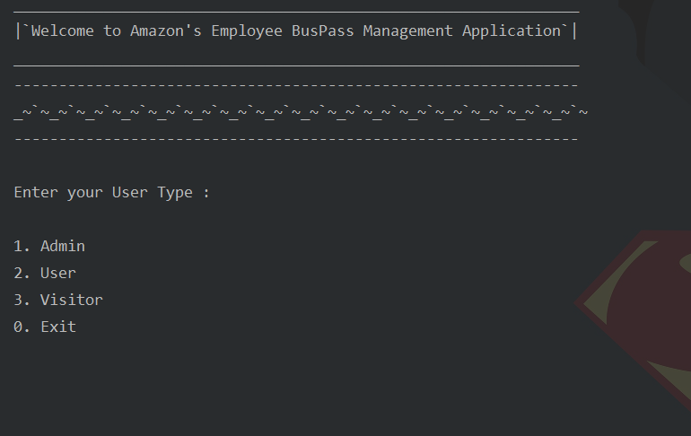

# **2.ADMIN LOGIN PAGE**

After entering ‘1’ in the Home Page, you will be requested for the Admin credentials.

*Default Admin ID* : ADMIN

*Default Admin Password* : ADMIN

Please make sure that all the credentials above are entered in *Upper Case*.

A successful login should display the Admin Operations page and should look like the below image :

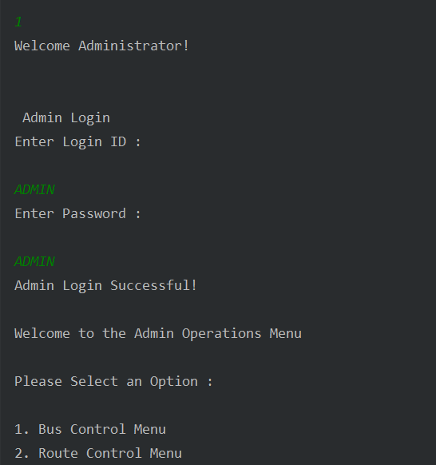

An unsuccessful login with incorrect credentials will give you a message and 3 tries to enter correct credentials which should look like the image below :

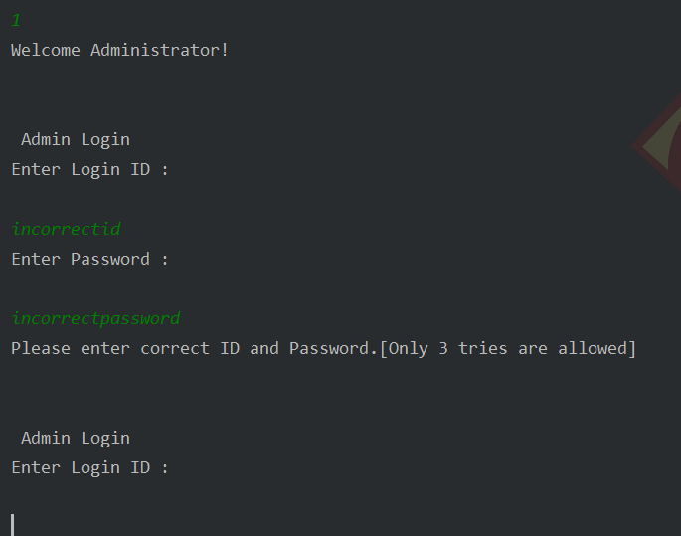

If you enter correct credentials within 3 tries, you will be logged in and taken to the Admin Operations page which should look like the image below :

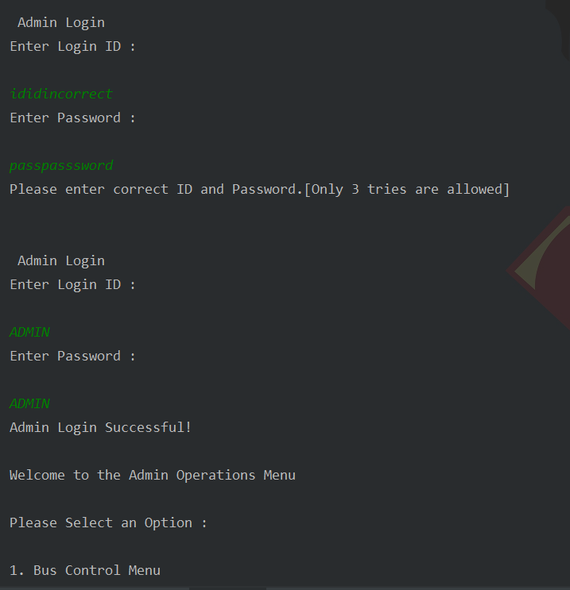

If you enter incorrect credentials for all the 3 tries, you will be taken to the application home page which should look like the image below :

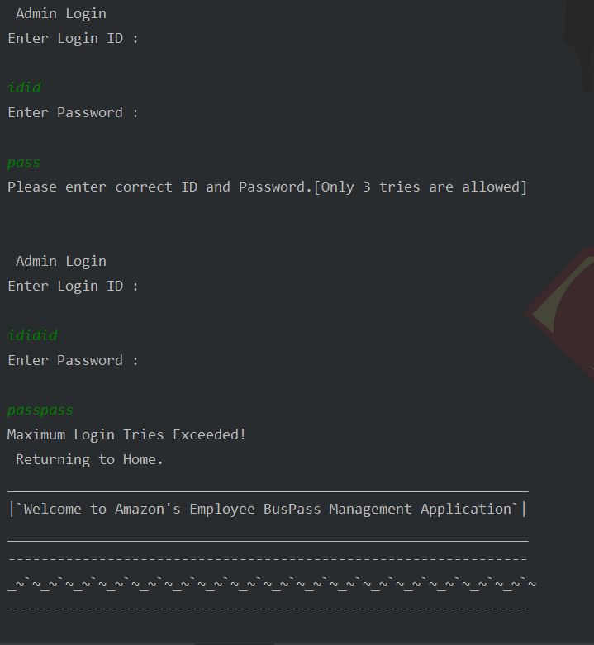

# **3. ADMIN OPERATIONS PAGE**

After a successful login, Admin Operations Page will be displayed.

## **3.0. Admin Operations Menu**

Here, you can enter the option of your choice and proceed to the tool page of your selection.

Following options are present under Admin Operations :

1. Bus Control Menu - To add/remove/view bus(es)

2. Route Control Menu - To add/remove/view routes and add stops

3. Change Bus & Route Assignments - Change schedule for each bus

4. Change Type of a Bus - Change capacity[bus type] for active/inactive buses.

5. Display Number of Buses of each Type

6. Display timings and route for each bus

0. Exit to Main Menu

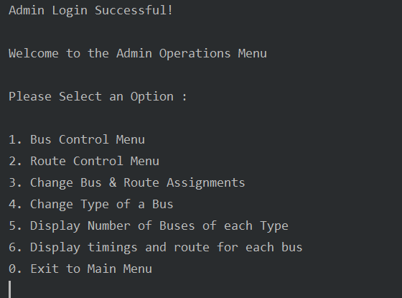

## **3.1. Bus Control Menu**

Here, you can enter the option of your choice and proceed to the tool page of your selection.

Following options are present under Bus Control Menu :

1. Add a New Bus - To add a new bus(es) in the fleet using a vehicle number and its type.

2. Remove an Existing Bus - To remove an Existing bus(es).

3. Show all Buses - To view details of all Buses, both active and inactive, present in the fleet.

0. Return to Admin Menu.

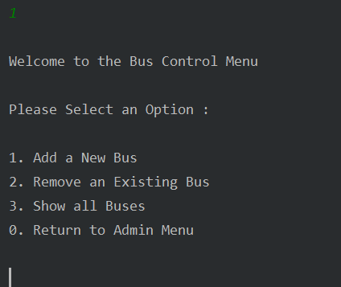

### 

### **3.1.1. Add a New Bus**

Following are the inputs required for adding a new bus to the fleet :

* Vehicle Number - Should be of format KA-15A-9999
* Bus Type- Should be non-negative and maximum bus type should be 50.

After successful add bus operation the bus will be assigned to a system generated unique id i.e the Bus ID. This Bus ID will be used throughout the application to identify this bus.

A successful add bus operation where all inputs are valid looks like the below image :

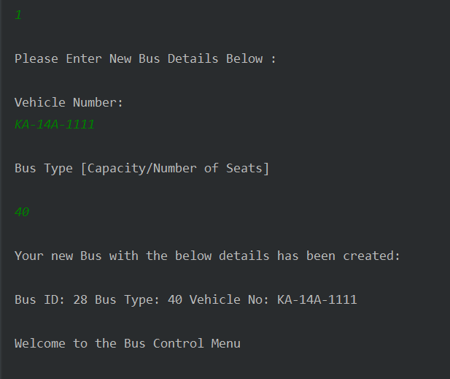

In case of invalid inputs :

|  |
| --- |
| * Input specific correction messages are displayed. |
| * In case of invalid entries the program returns to the Bus Control Menu. |

Below are few images for unsuccessful scenarios where invalid inputs were entered :

Vehicle Number input in invalid format

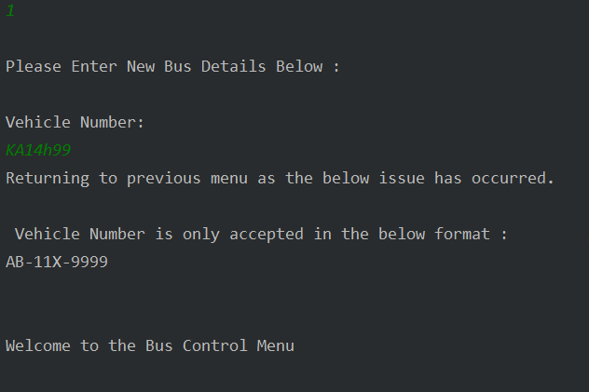

Bus Type input is negative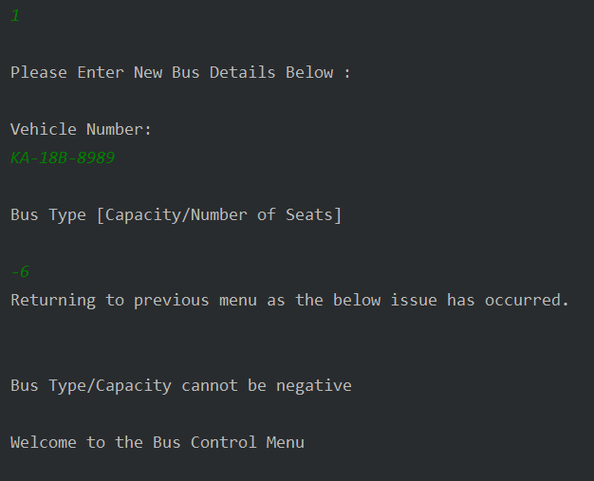

Bus Type input exceeds limit

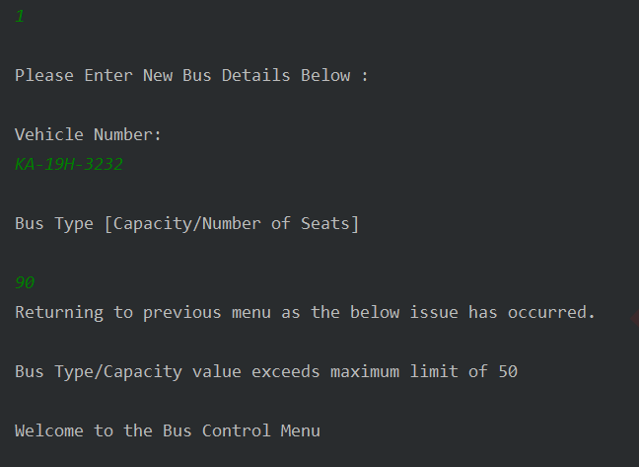

### **3.1.2. Remove an Existing Bus**

For your reference, the list of all buses in the current fleet is displayed.

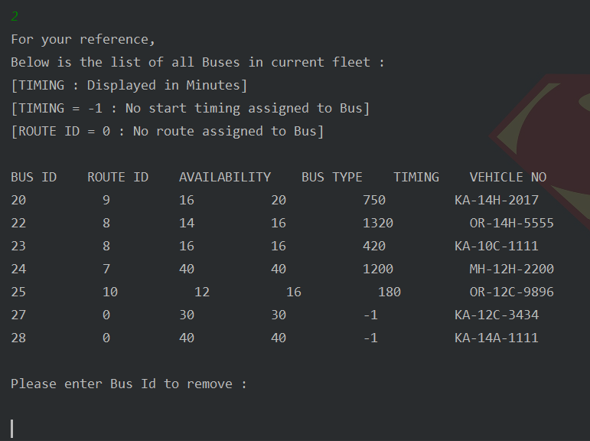

|  |
| --- |
| You have to enter the Bus ID of the bus which has to be deleted.  If input is valid, the bus record is removed from our system. |
|

Successful bus remove operation will display the updated bus fleet information like the below image:

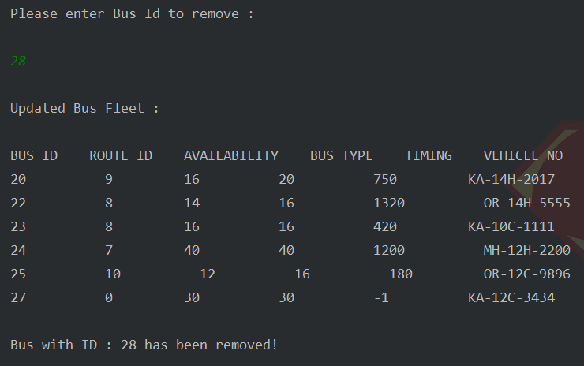

|  |  |  |
| --- | --- | --- |
| In case of invalid inputs :   |  | | --- | | * Input specific correction messages are displayed. | | * In case of invalid entries the program returns to the Bus Control Menu. | |
|  |
|  |

For invalid input, below image is displayed:

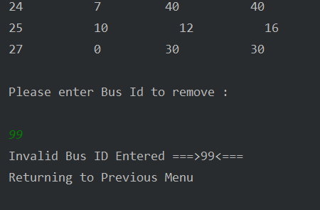

**3.1.4. Show All Buses**

The list of all buses in the current fleet is displayed.

Information for all buses in the fleet is displayed like the below image:

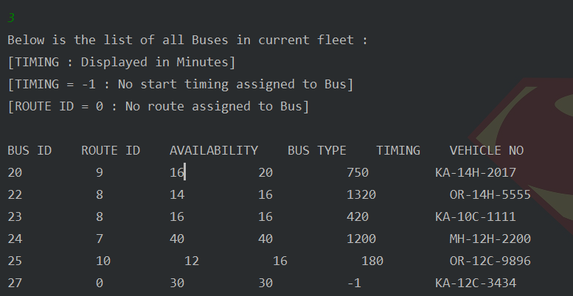

## **3.2. Route Control Menu**

Here, you can enter the option of your choice and proceed to the tool page of your selection.

Following options are present under Route Control Menu :

1. Add a New Route - To add a new route based on multiple stops..

2. Remove an Existing Route - To remove a route.

3. Add a new Stop - To add a new stop in the system.

3. View all routes with their stops - To view details of all routes with their stops.  
0. Return to Admin Menu.

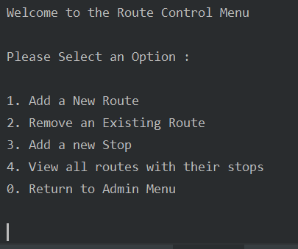

### **3.2.1. Add a New Route** Number of stops should be non-negative and should be at max 10. For a valid number of stops:

* Displays currently available stops list.
* Then asks for Stop Ids one by one
* After successful add route operation a unique system generated route id is assigned

and displays a list of updated routes.

Entering a valid number of stops, displays list of available stops like the below image: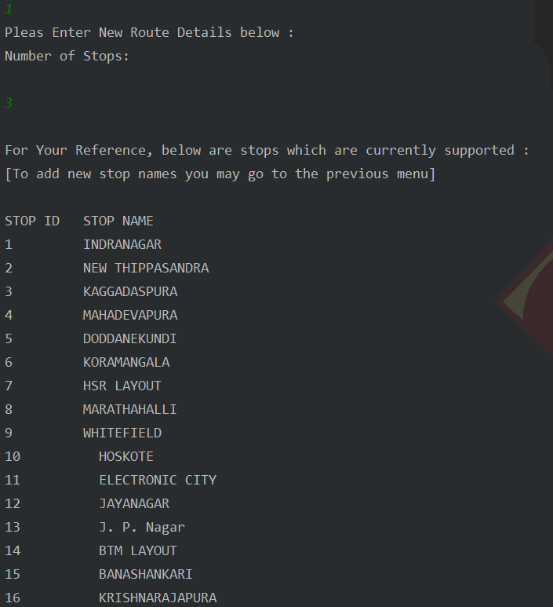

A successful add route operation with valid inputs will look like the below image:

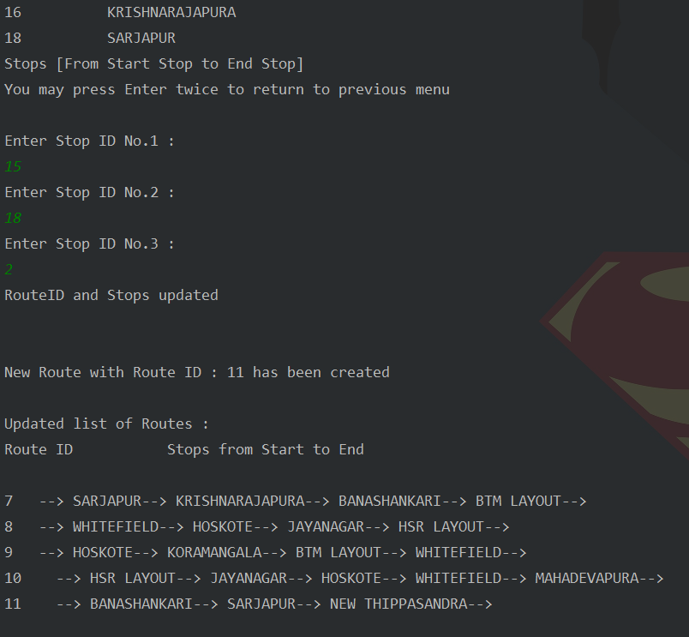

For invalid number of stops or stop ids:  
- Displays input specific correction message  
- Then returns to Route Control Menu

Below are images for a few unsuccessful scenarios where invalid inputs were entered.

Incorrect Number Of Stops:

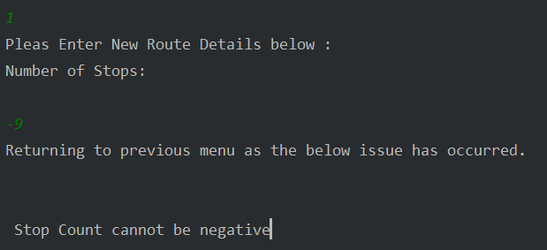

Number Of Stops exceeding limits:

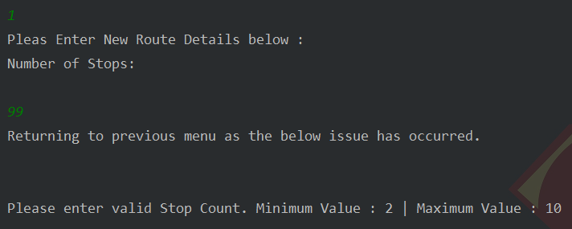

Invalid Stop ID:

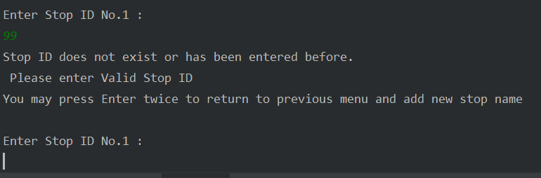

Letters instead of Stop ID number:

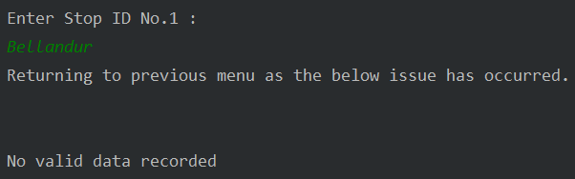

Repeating Stop IDs:

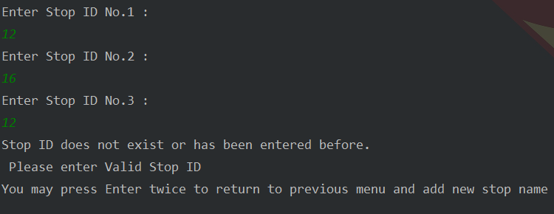

### **3.2.2. Remove an Existing Route**

For user reference, the list of all the routes is displayed.  
User has to enter Route ID for the Route which has to be deleted.  
If the input is valid then the Route record is removed and its bus assignments are cleared.  
Then the updated Route List is displayed.  
Then to the Route Control Menu.

List of available routes are displayed for reference:

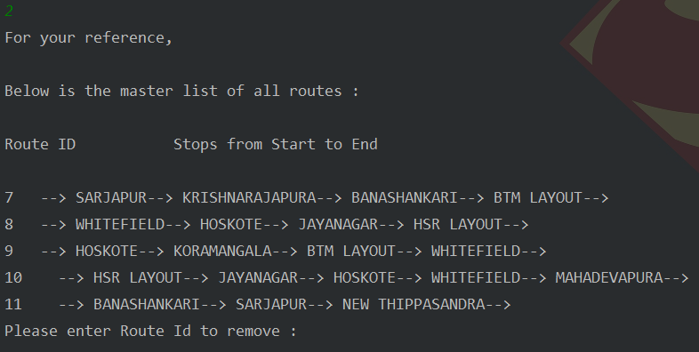

A successful remove route operation should look like the below image: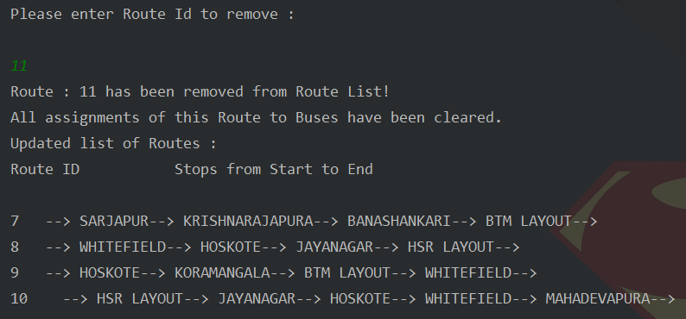

If input is invalid:  
- Displays input specific correction message  
- Then returns to Route Control Menu

Below are images for unsuccessful scenarios where invalid inputs were entered :

Invalid Route ID:

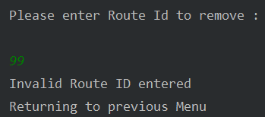

Letters instead of Route ID number:

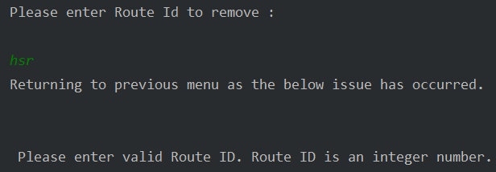

### **3.2.3. Add a New Stop**

For user reference currently available stops list is displayed.  
User has to enter the stop name.  
If input is valid, the stop is added and an updated stop list is displayed.  
List of Available stops is displayed for reference:

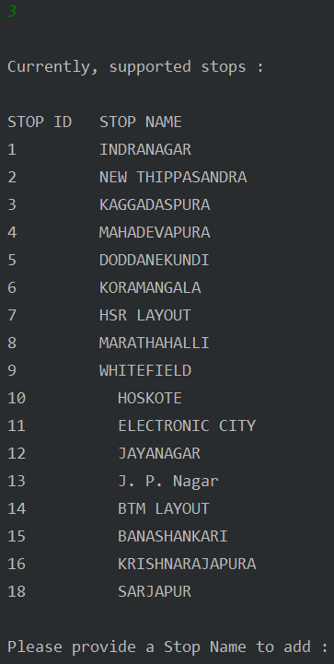

A successful add route operation should look like the below image:

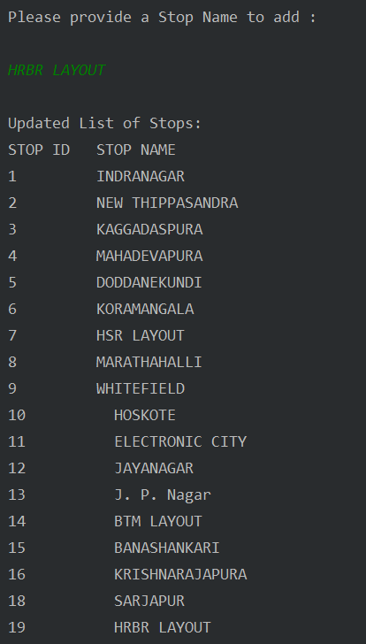

If input is invalid:  
- Displays input specific correction message  
- Then returns to Route Control Menu

Below are images for few unsuccessful scenarios where invalid inputs were entered :

Numbers Entered instead of Stop Name:

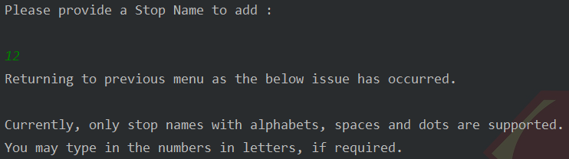

### **3.2.4. View All Routes With Their Stops**

Current Route List and returns to Route Control Menu Displayed.  
Information for all routes present in the system:

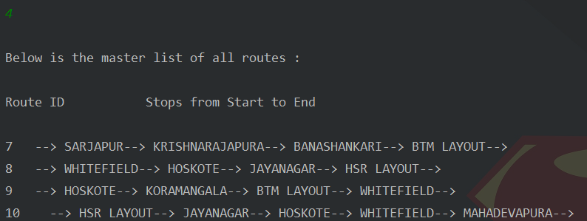

## **3.3. Change Bus & Route Assignments**

For user reference current Bus and Route Assignments list is displayed.

* User has to enter the Bus Id, if the input is valid, it Stores the Value and displays in the newly created Bus.
* Updated Bus and Route Assignments list is displayed.

For reference, current bus and route assignment information displayed

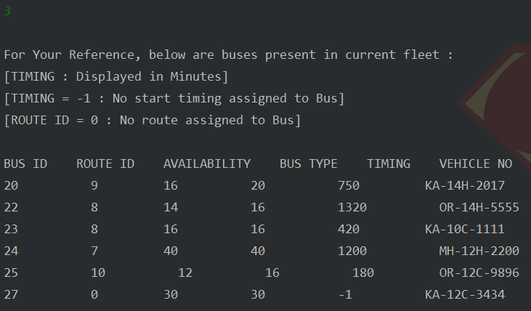

For valid Bus ID, currently available routes and stops are displayed

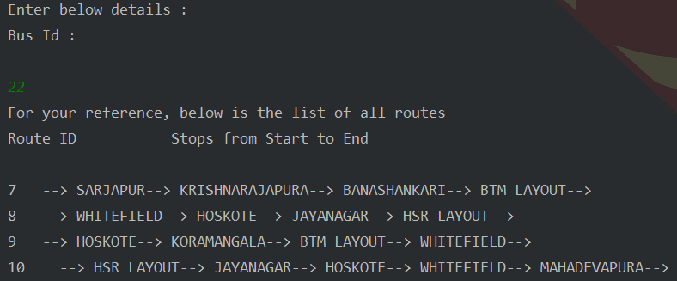

A successful Bus and Route assignment operation will look like the below image:

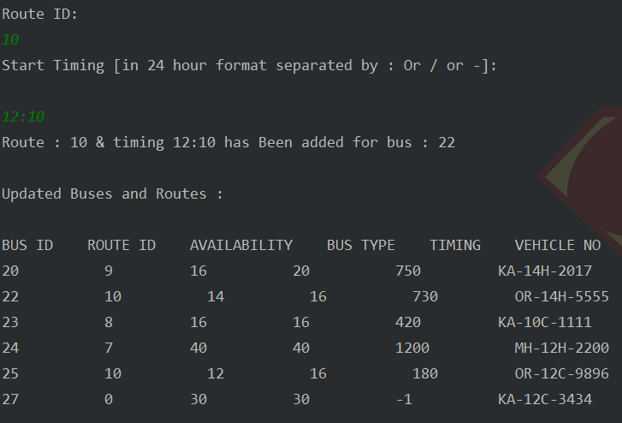

If any of the inputs are invalid:   
- Displays input specific correction message  
- Then returns to Admin Operations Menu

Below are few images for unsuccessful scenarios where invalid inputs were entered :

Invalid Bus ID

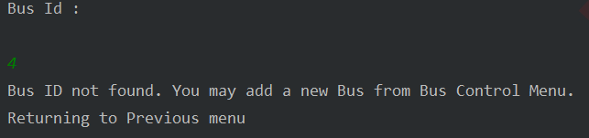

Invalid Route ID

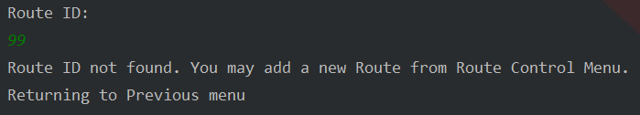

Invalid Start Timing

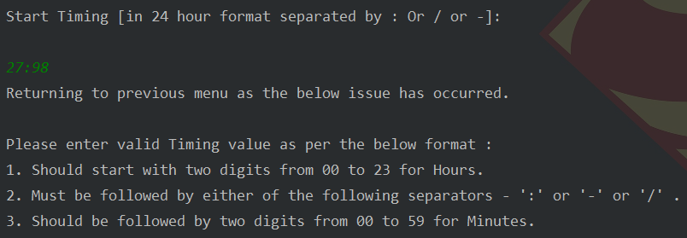

## **3.4. Change Bus Type Menu**

## 

### **3.4.1. Change Type Of an Active Bus**

Active buses have a Route ID assigned to them  
Current Bus Details list is displayed.

Route Id and Bus Id should be valid i.e it should be present in the list.

Bus Type should be non-negative and at max 50.  
And a valid vehicle number in the format KA-14X-9999 should be entered.

Current Bus and Route assignment information is displayed for reference

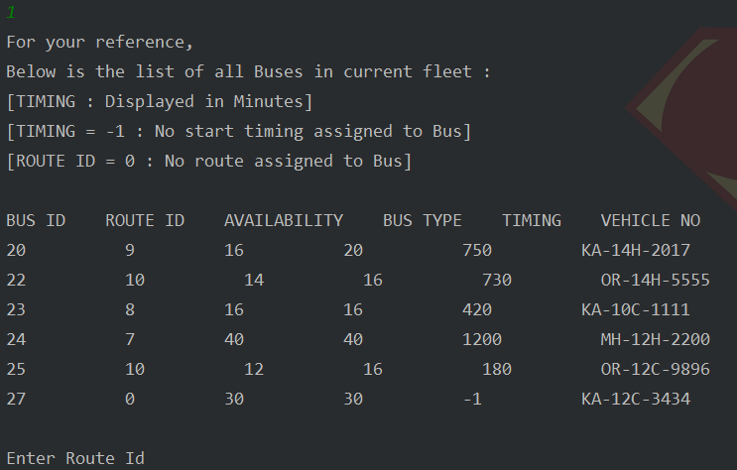

A successful Change Bus Type operation for an active bus should look like the below image:

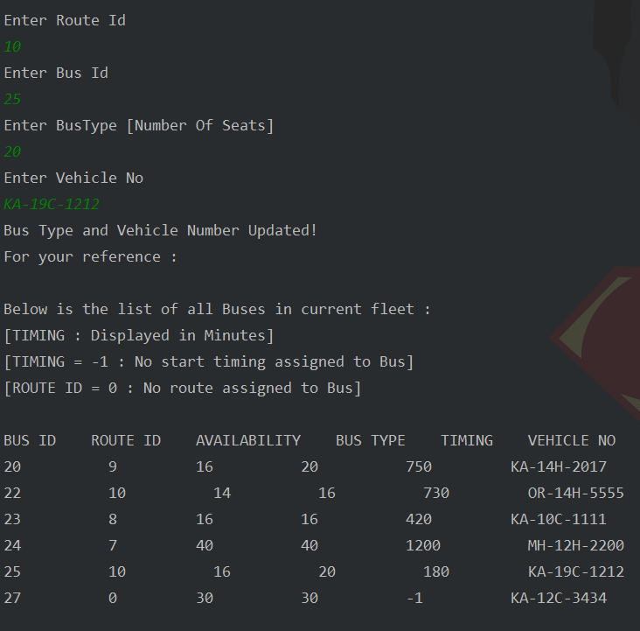

If any of the inputs are invalid:   
- Displays input specific correction message

- Then returns to Change Bus Type Menu

Below are images for few unsuccessful scenarios where invalid inputs were entered :

Inactive Route ID

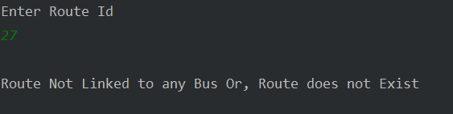

Invalid or Inactive Bus ID

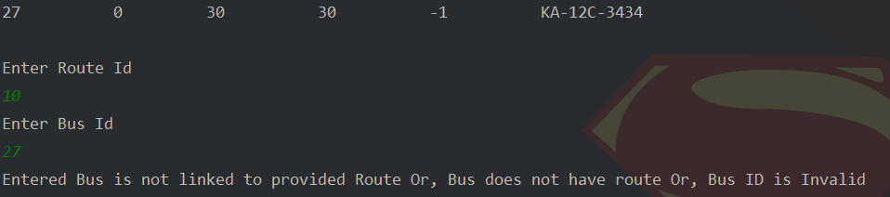

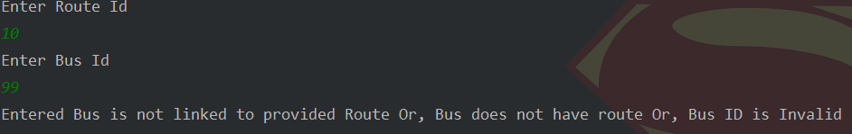

Bus Type does not support currently occupied seats

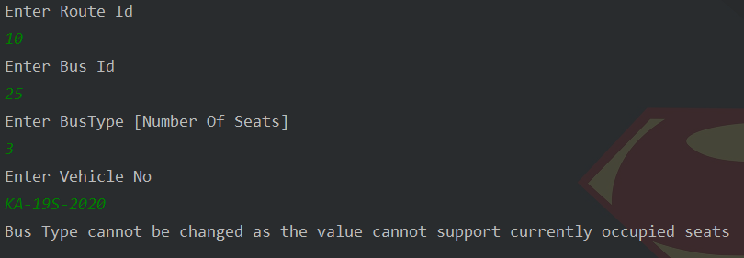

### **3.4.2. Change Type Of an Inactive Bus**

Inactive buses, which do not have any routes assigned on them.  
Current Bus Details list is displayed.

Bus Id should be valid i.e it should be present in the list.

Bus Type should be non-negative and at max 50.  
And a valid vehicle number in the format KA-14X-9999 should be entered.

Current Bus and Route assignment information is displayed for reference:

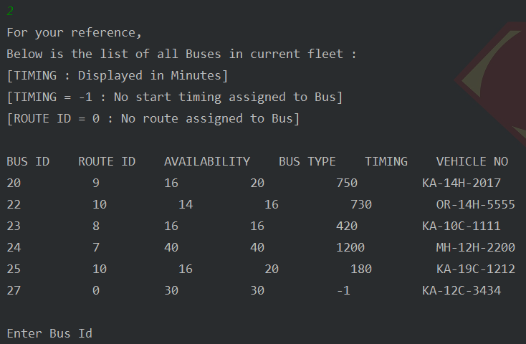

A successful Change Bus Type operation for an inactive bus should look like the below image:

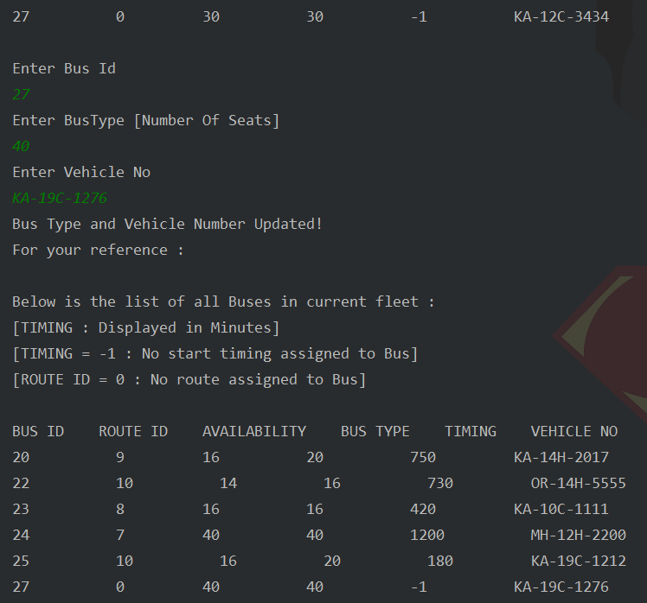

Below is an image for few unsuccessful scenarios where invalid inputs were entered :

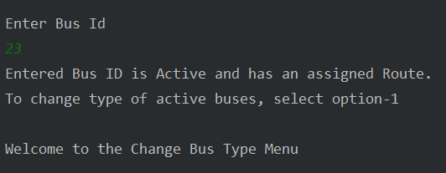

### **3.4.3. Show All Buses**

current Bus Details list is displayed:

Displays details of all the buses in current fleet:

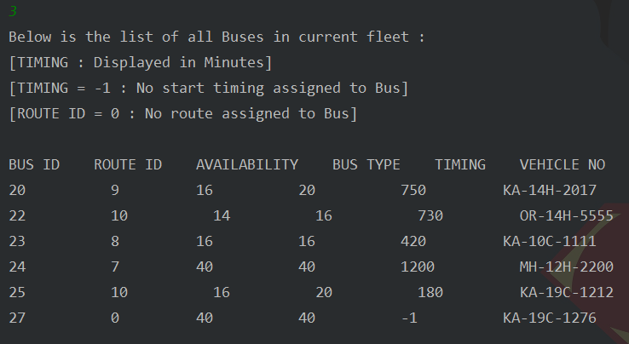

## **3.5. Display Number of Buses Of Each Type**

Bus type and their count details i.e the number of seats is displayed.

Displays the number of buses present for each type[capacity]

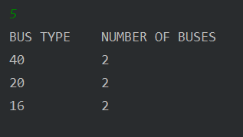

## **3.6. Display Start Timings And Route For Each Bus**

Schedule for active Buses with each route and timing is displayed.

Displays the complete schedule for all active and available buses with their route details:

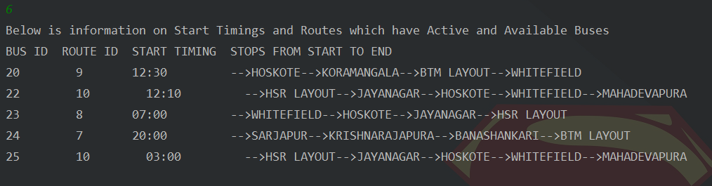

# **4. USER LOGIN/SIGNUP PAGE**

## 

## **4.1. Existing User**

After entering ‘2’ in the Home Page, you will be requested for the user credentials.

2 Test User accounts have already been created for testing.

User without a Bus Pass login details:

*User ID*  : 123451234

*Password* : biku1234

User with a Bus Pass login details:

*User ID*  : 123412341

*Password* : vino1234

Please make sure that all the credentials above Or, any new account created from your end are entered correctly to login as an existing user.

A successful login should display the User Operations page which looks like the below image :

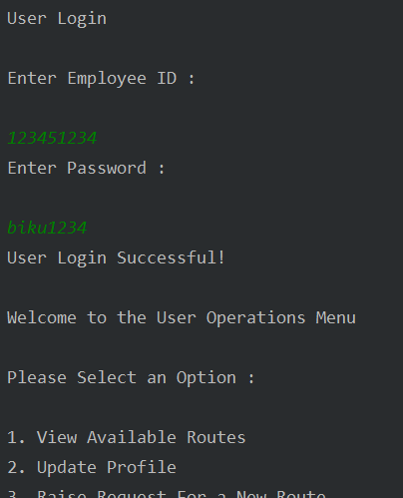

An unsuccessful login with incorrect credentials will give you a message and 3 tries to enter correct credentials which should look like the image below :

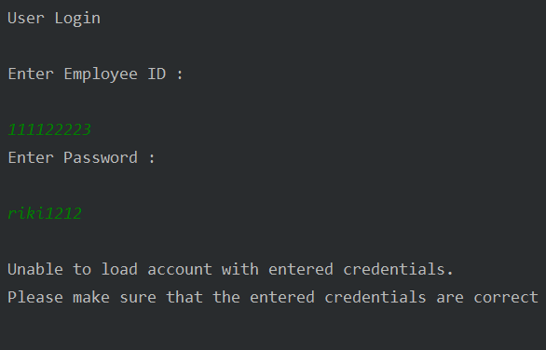

If you enter correct credentials within 3 tries, you will be logged in and taken to the UserOperations page.

If all the 3 tries are exhausted, the user login/signup page is be displayed:

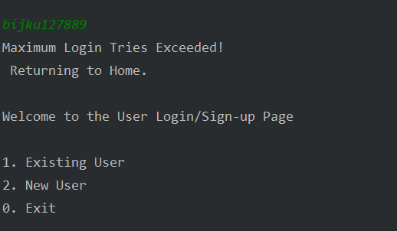

Below are images for unsuccessful scenarios where invalid inputs were entered :

Invalid Employee ID:  
Employee ID is the 9 digit number provided to all Amazon employees.

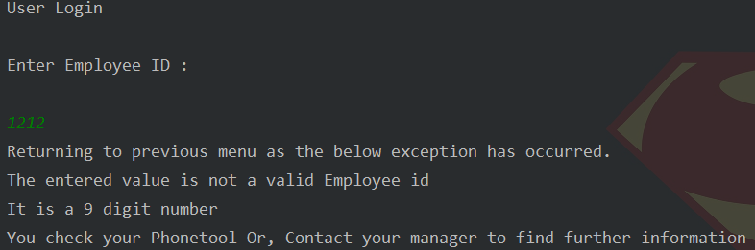

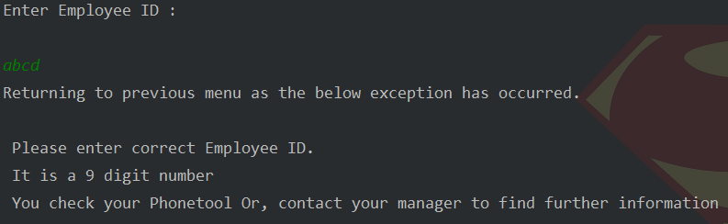

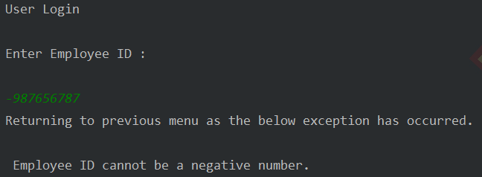

Password must be of at least 8 characters, consisting of only letters and digits, there should be

a minimum of two digits in it.

Invalid Password:

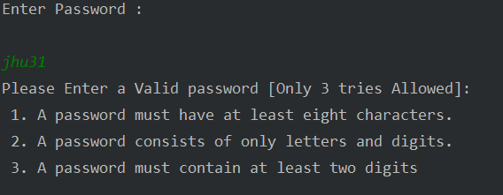

## 

## 

## 

## **4.2. New User**

Employee Id should be of 9 digits.  
First Name and Last Name should be only alphabets.  
Email Address should be in format xyz@amazon.com or abc@gmail.com.  
Contact number should be of 10 digits or 12 digits with country code.

Emergency Contact number should be of 10 digits or 12 digits with country code.  
Emergency Contact Name should be only alphabets.

Blood Group should be in the format ABPOSITIVE.

Password must be of at least 8 characters, consisting of only letters and digits, there should be

a minimum of two digits in it.

A successful account creation will look like the below images:

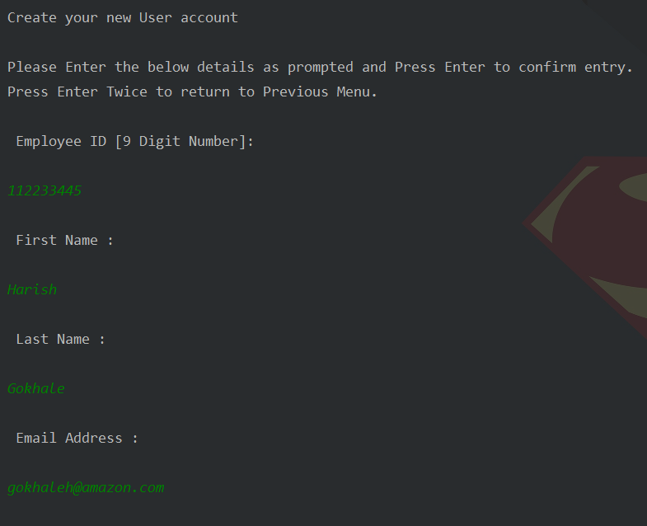

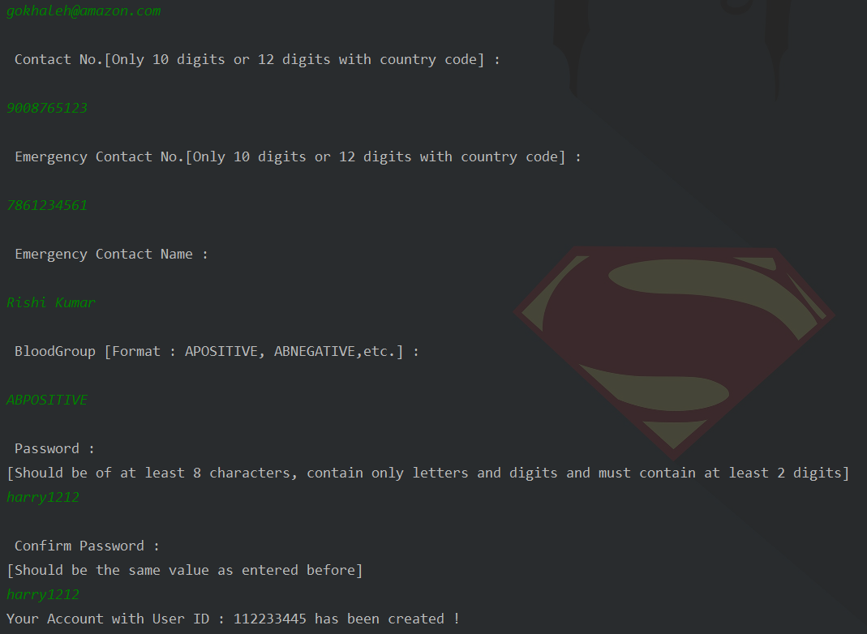

And you will be asked to log-in with your new account’s credentials:

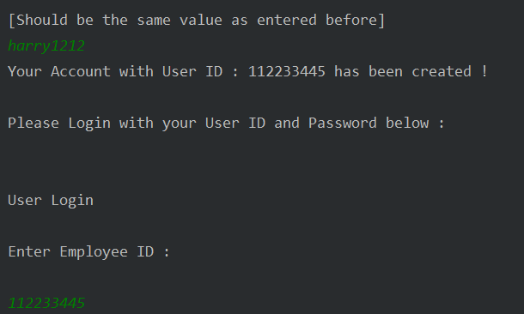

If any of the inputs are invalid:

- Displays input specific correction message

- Then displays User Login/Signup Menu

Below are few images for unsuccessful scenarios where invalid inputs were entered :

Invalid Name:

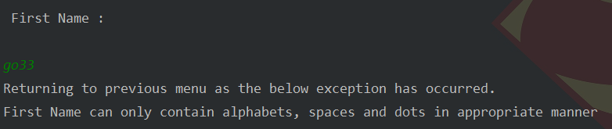

Invalid Email Address:

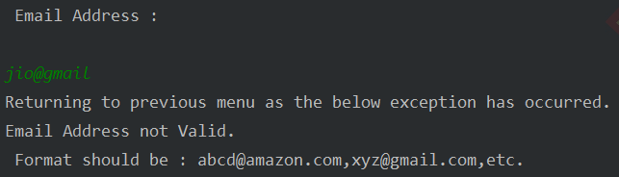

Invalid Phone Number:

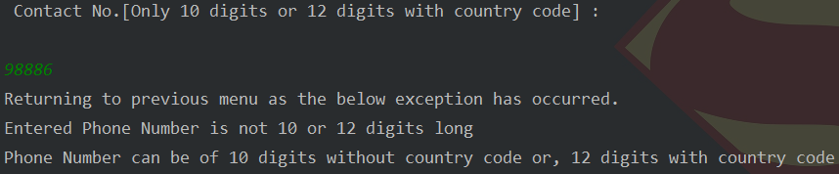:

Invalid Blood Group:

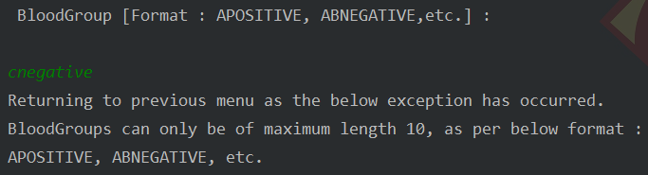

3 Password attempts are allowed for entering password as well as confirming the password

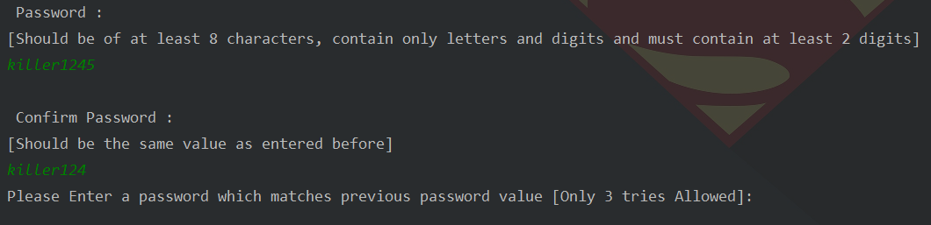

If exhausted, user login/signup page is displayed.

# **5. USER OPERATIONS PAGE**

After a successful login, the User Operations Page will be displayed.

## **5.0 User Operations Menu**

Here, you can enter the option of your choice and proceed to the tool page of your selection.

Following options are present under User Operations Menu :

1. View Available Routes - To view all the available routes.

2. Update Profile - to update profile information.

3. Raise Request For a New Route - to request for a new route.

4. Raise Request for a Bus Pass - requesting bus pass to avail the bus services.

5. Provide Feedback - any feedback or issues related to the bus service.

0. Return to Admin Menu.

## 

## **5.1. View Available Routes**



Displays the complete schedule for all active and available buses with their route details.

## **5.2. Update Profile**

Here, you can enter the option of your choice and proceed to the tool page of your selection.

Following options are present under Update Profile Menu :

1. Name - To update Name.

2. E-mail address - To update E-mail address.

3. Contact Number- To update Contact Number.

4. Emergency Contact Details- To update Emergency Contact Details.

5. Blood Group- To update Blood Group.

6. Password - To update Password.

0. Return to the User Menu.

### **5.2.1. Update Profile - Field Selection Menu**

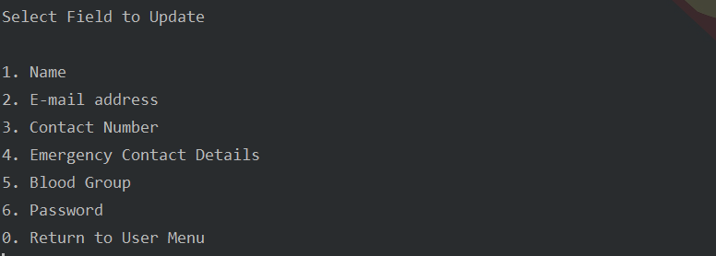

### **5.2.2. Update Name**

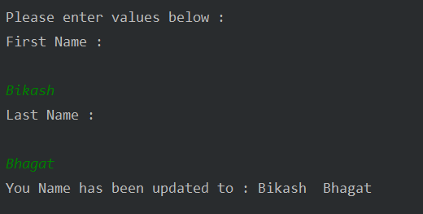

Below is an image for unsuccessful scenarios where invalid input was entered :

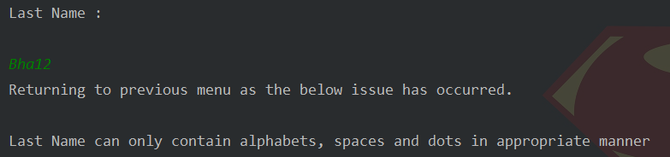

### 

### **5.2.3. Update Email Address**

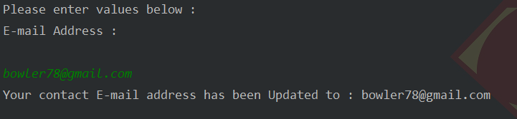

Below is an image for unsuccessful scenarios where invalid input was entered :

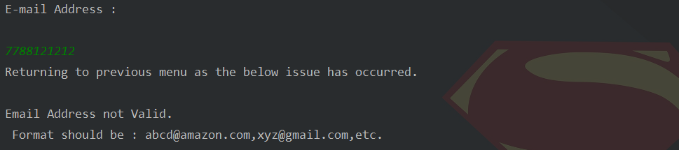

### **5.2.4. Update Contact Number**

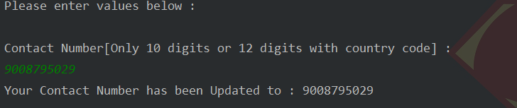

Below are few images for unsuccessful scenarios where invalid inputs were entered :

Letters for Phone Number

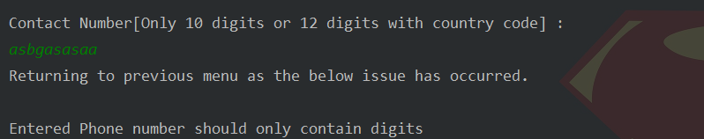

Invalid Phone Number Format

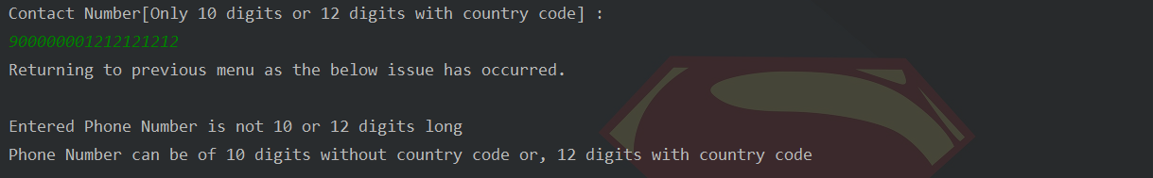

### **5.2.5. Update Emergency Contact Details**

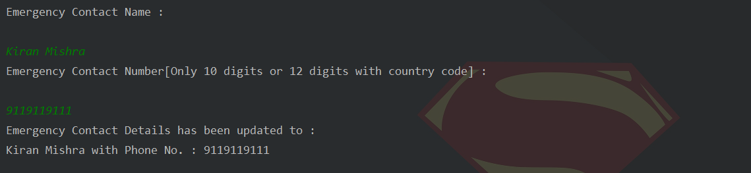

Below is an image for unsuccessful scenarios where invalid input was entered :

Invalid Name:

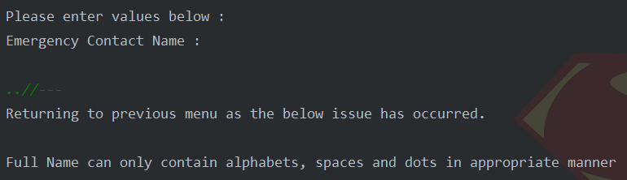

### **5.2.6. Password**

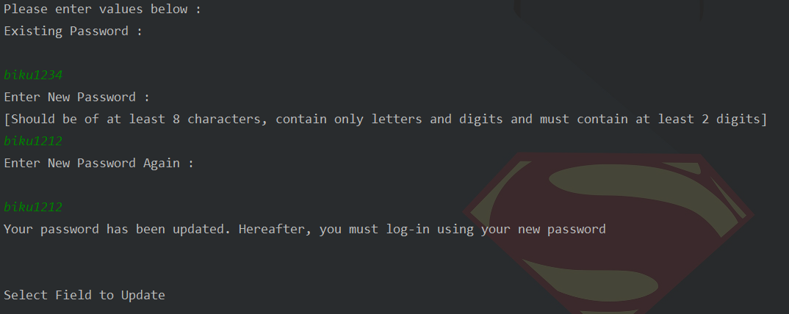

3 tries each are provided to enter existing, new and confirm new password fields.

If you enter incorrect value in any of the fields you can correct it within 3 tries.

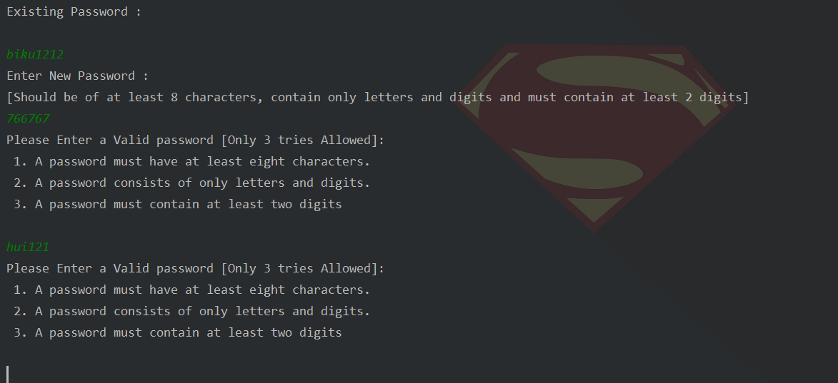

## **5.3. Raise Request For a New Route**

For user reference available Stops List and asks for required inputs for Stop Names[New or Existing] and Start Timing is displayed.  
Enter Start Stop Name in alphabets.  
Enter End Stop Name in alphabets.

Start timing should be in the following format 14:30 or 14/30 or 14-30.

List of currently available Stops is displayed for reference:

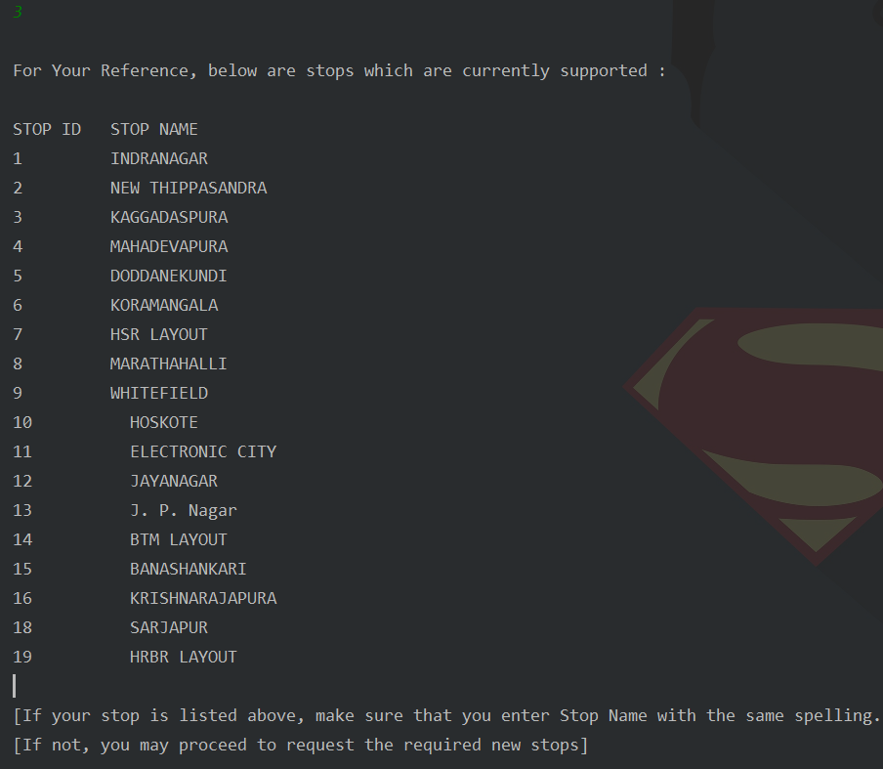

A successful route request should look like the below image:

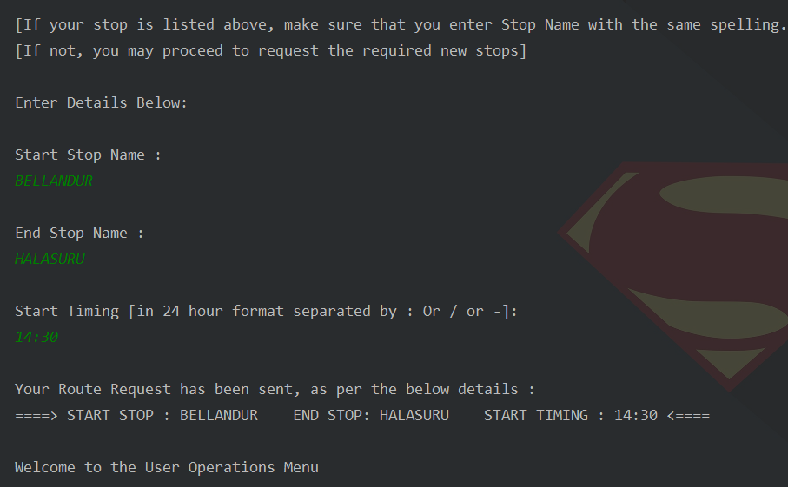

If any of the inputs are invalid:   
- Displays input specific Correction Message  
- Then displays the User Operations Menu

Below is an image for a few unsuccessful scenarios where invalid inputs were entered.

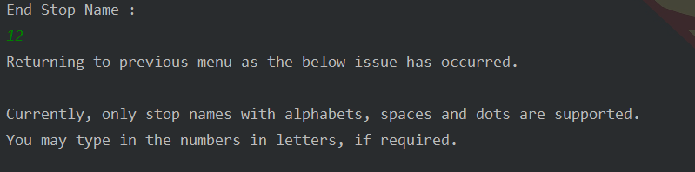

## **5.4. Raise Request For a Bus Pass**

Here, you can request for a bus pass to start using our service.

In case you already have a Bus Pass, you will be unable to request another one.

Otherwise, a user reference Schedule for active Buses with each route and timing , and asks for inputs is displayed.

Route ID should be an existing Route ID or else user can request for a new route by going back.

Start time should be in the format 3:00 or 3-00 or 3/00.

If all inputs are valid, the bus pass is created with a system generated unique Id.

Complete schedule for all active and available buses with their route details is displayed for reference.

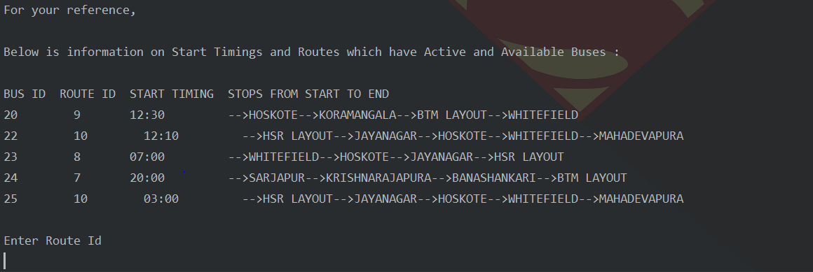

If the inputs are valid, a BusPass will be assigned to the user, and availability for the vehicle will be reduced.

A successful Bus Pass request should look like the below image

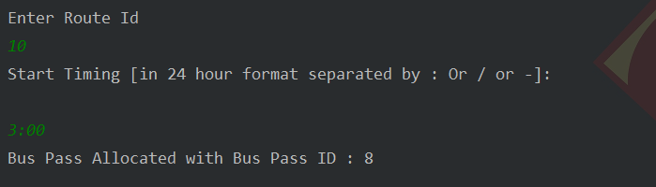

If a Bus Pass is already assigned for the user, no further requests will be taken.

Below is the image for a user with existing bus pass:

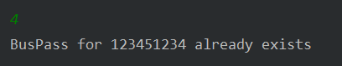

If input is valid:  
- Displays input specific correction message  
- Then displays the User Operations Menu

Below are images for a few unsuccessful scenarios where invalid inputs were entered.

Invalid Route ID:

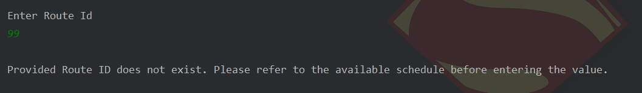

Invalid Start Timing:

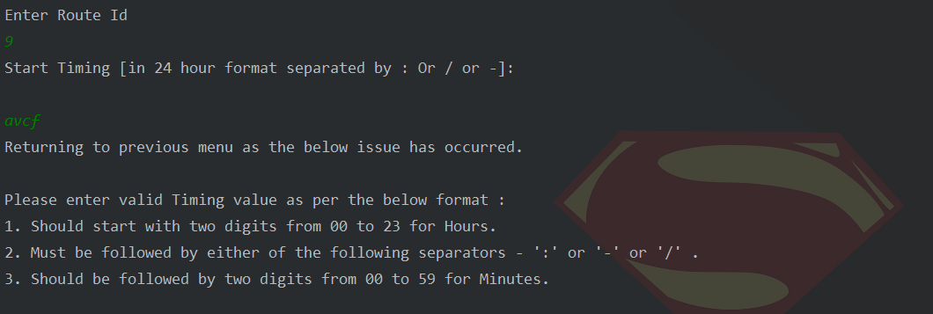

## **5.5 Provide Feedback**

Here, you [an existing user] can provide feedback on your experience or ask questions about the service.

We have a limit of 100 words for any feedback.

.

If your Feedback has been successfully accepted on our system, it should look like the below image:

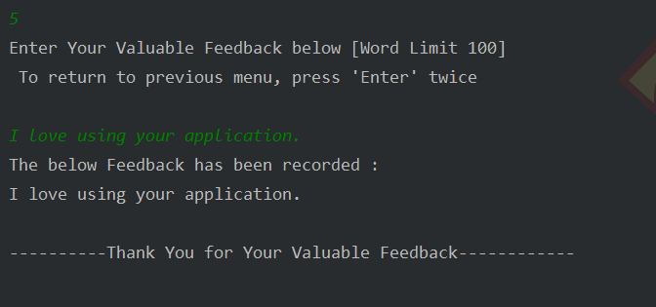

Below are images for unsuccessful scenarios where invalid inputs were entered:

Blank Comment:

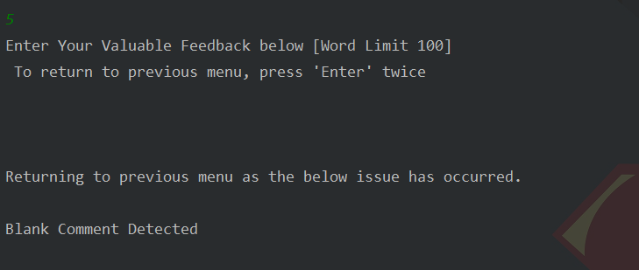

Comment exceeds character limit:

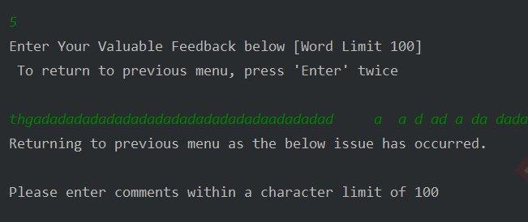

# **6. Visitor Operations Page**

After entering ‘3’ in the Home Page, you will be shown the Visitor Operations Page.

## 

## **6.1. Visitor Operations Menu**

The Visitor Operations menu displays below features accessible to a visitor who does not have an existing account and only wants to get general information on the service.

## 

## **6.2. View Details For Available Routes and Buses**

## 

Displays the complete schedule for all active and available buses with their route details.

The Start Timing is displayed in 24-Hour format.

All stops present in a route are displayed from Start to End stop.

## **6.3. Display Seat Availability**

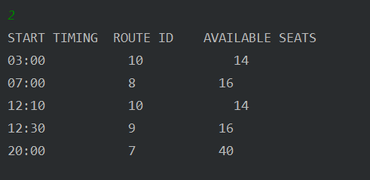

Displays the seat availability for a Start timing and the buses running on the Route [may include multiple buses].

# 

# **7. A Message From The Creator**

Thank You for reading through the application manual.

I recommend trying out the application on your own, to see it in action.

Have an amazing day!

# 